Documentation for Simulink Model

**A. Files & Folder**

1. test_model_ver1.slx: First version of the Simulink model.

2. data folder: The folder contains the data used for this Simulink model. There are two data set. One is a simple toy data set for the model debugging. The other is a test HFR dataset from real experiment.

3. model_specs folder: The folder contains the model specifications for the LSTM model and MLP model used in Simulink. The specifications shall be loaded to Simulink automatically once the Simulink is open.

**B. Model Overview:**

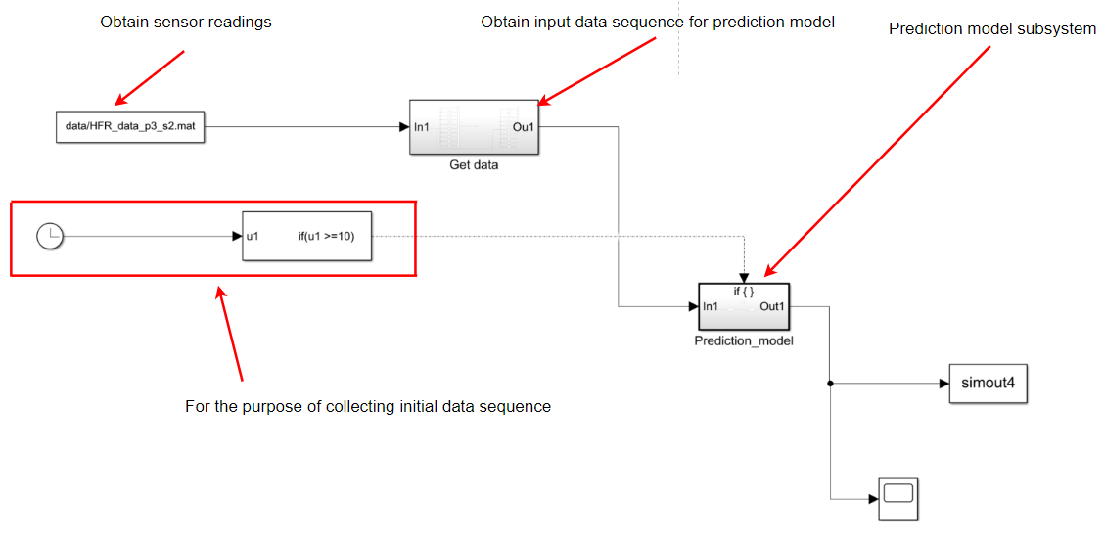

“Get data” subsystem: 9 previous signal + current signal

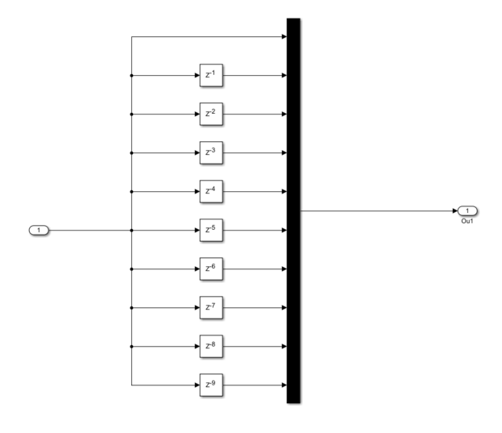

Prediction model subsystem: LSTM model + MLP model

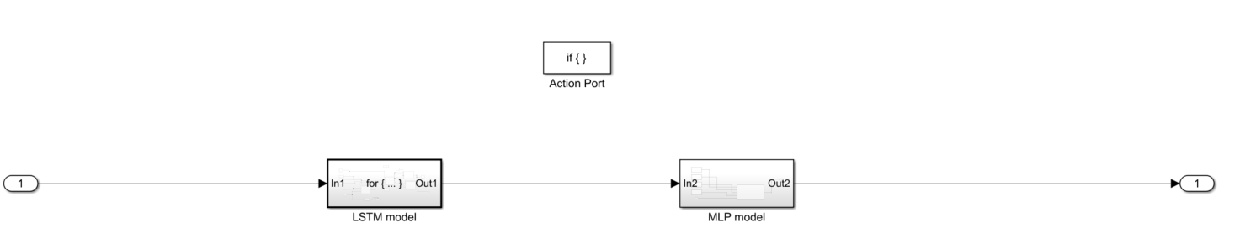

LSTM model subsystem: calculate LSTM model output at current time. This is implemented using a “for loop iterator”. The MATLAB function blocks are explained in the last MATLAB code documentation.

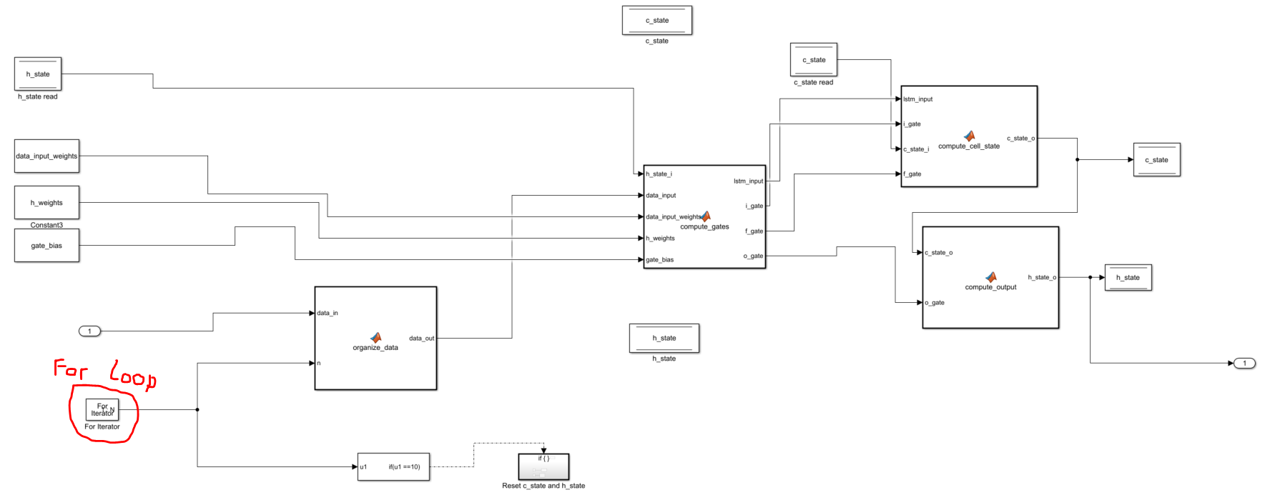

MLP model: The model uses the last output of LSTM model as the input. The MATLAB function block is explained in the last MATLAB documentation.

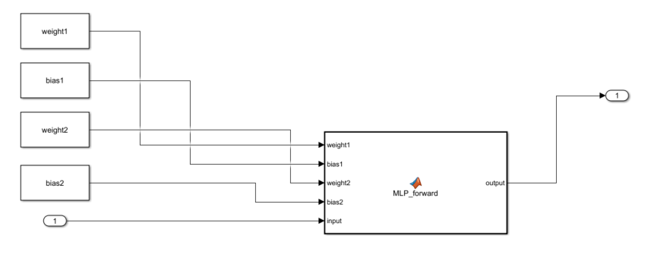

**B. Input data:**

“HFR_data_p3_s2.mat” file is one of the test dataset from experiment. This file is a resampled signal from the original dataset. The sampling rate is 1 point every 20 points. The original dataset has sampling rate of 10 Hz. Thus, this new dataset has the sampling rate of 0.5 Hz.

The current model uses 10 look back steps. This means that for the prediction at t=20, it uses the data collected from t= 1 to t=20.

For the Simulink model, the initial data signal is assumed to be zero. You can verify this by checking the first column of “HFR_data_p3_s2.mat”.